Quinn Knudsen

Homework 5

Topic: **Statistical Inference Part II**

6)

> t.test(PlantGrowth$weight[PlantGrowth$group=="ctrl"],PlantGrowth$weight[PlantGrowth$group=="trt1"])

Welch Two Sample t-test

data: PlantGrowth$weight[PlantGrowth$group == "ctrl"] and PlantGrowth$weight[PlantGrowth$group == "trt1"]

t = 1.1913, df = 16.524, p-value = 0.2504

alternative hypothesis: true difference in means is not equal to 0

95 percent confidence interval:

-0.2875162 1.0295162

sample estimates:

mean of x mean of y

5.032 4.661

The observed value of t is 1.19, with 16.52 degrees of freedom, and a p value of .25. This p value is greater than .05 indicating that we have failed to reject the null hypothesis that the values are equal. The confidence interval spans from -.29 (lower) to 1.03 (upper) clearly cross the 0 threshold indicating or inability to determine whether the values are different from one another.

7)

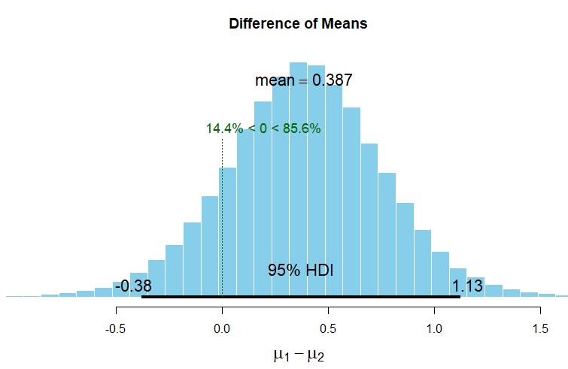

The histogram shows the 100,000 steps the MCMC “robot” took exploring the mean difference between the two groups. On average, the difference in the means was 0.387. The 95% HDI shows the highest density interval also known as the credible interval (95% of the robots’ steps were in the range of -0.38 and 1.13). This is where the robot spent the majority of its time searching for the mean difference. 14.4% of the robots’ searches were less than 0 and 85.6% of the robots’ searches were above zero.

**There’s a 95% chance that the population mean difference between the two grou-ps falls within the boundaries of this HDI.**

> plantBEST <- BESTmcmc(PlantGrowth$weight[PlantGrowth$group=="ctrl"],

+ PlantGrowth$weight[PlantGrowth$group=="trt1"])

Waiting for parallel processing to complete...done.

> plot(plantBEST)

> summary(plantBEST)

mean median mode HDI% HDIlo HDIup compVal %>compVal

mu1 5.028 5.027 5.056 95 4.579 5.471

mu2 4.641 4.638 4.617 95 4.036 5.262

muDiff 0.387 0.388 0.372 95 -0.380 1.126 0 85.6

sigma1 0.662 0.623 0.561 95 0.347 1.067

sigma2 0.896 0.844 0.772 95 0.447 1.438

sigmaDiff -0.234 -0.214 -0.173 95 -0.948 0.417 0 21.9

nu 34.172 25.597 10.343 95 1.301 92.713

log10nu 1.378 1.408 1.478 95 0.595 2.086

effSz 0.510 0.504 0.459 95 -0.439 1.456 0 85.6

> plotAll(plantBEST)

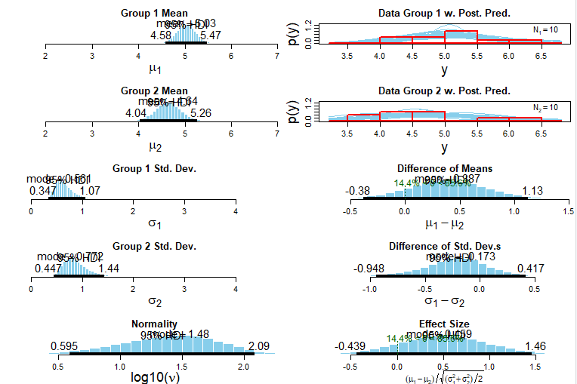

8)

From a research perspective, the positive takeaway is that there is consistency amongst the findings in that the means estimation is both above and below a zero value making it difficult to discern a difference in the sample of population. The null hypothesis significance test exceeds an acceptable p value to confidently reject the null hypothesis that the means are the same and the confidence interval spans from -.28 to 1.03 giving a range of values that are associated with a nonsignificant finding. The HDI demonstrates a similar numeric finding that when compared to the range from the NHST estimating that there is a 95% chance the population mean falls between -0.38 and 1.13. The consistency provides insufficient evidence to make a claim that the mean of the control group is different from the mean of the treatment group.

9)

> t.test(PlantGrowth$weight[PlantGrowth$group=="ctrl"],PlantGrowth$weight[PlantGrowth$group=="trt2"])

Welch Two Sample t-test

data: PlantGrowth$weight[PlantGrowth$group == "ctrl"] and PlantGrowth$weight[PlantGrowth$group == "trt2"]

t = -2.134, df = 16.786, p-value = 0.0479

alternative hypothesis: true difference in means is not equal to 0

95 percent confidence interval:

-0.98287213 -0.00512787

sample estimates:

mean of x mean of y

5.032 5.526

The t-test provides us with evidence to reject the null hypothesis that the mean of the treatment group 2 and the control are equal based upon a p value below the set threshold of .05. Directionally, the confidence interval helps us make a determination that the mean of x is lower than y with a 95% range of -0.98 to -0.01. The effect size of this mean difference is not tested here, but could be quite small based upon the lower end of the confidence interval being so close to zero.

The Bayesian method helps support our initial findings with the NHST by providing an estimated population difference of -0.49 and a 95% chance that the population mean difference between the two groups falls within the boundaries of the HDI (-1.05;0.07). The HDI boundaries differ from the confidence interval because they actually include a positive difference. Here, the Bayesian method estimates 4.2% of the searches by the robot were conducted at a level above zero. This is still insignificant in magnitude when compared to the 95.8% of searches that place the mean as a negative value.

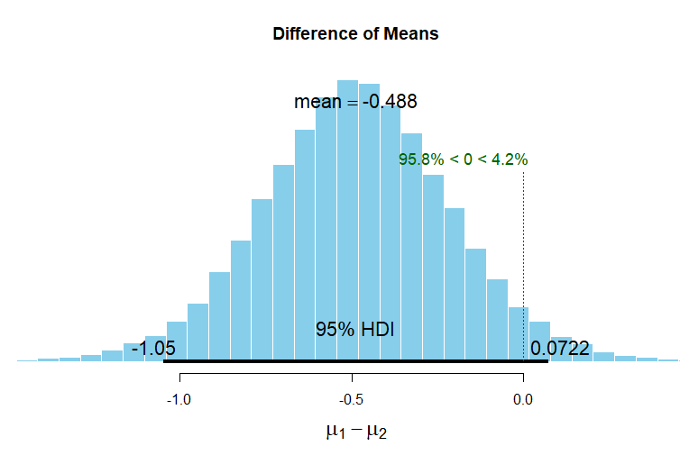

> plantBEST2 <- BESTmcmc(PlantGrowth$weight[PlantGrowth$group=="ctrl"],

+ PlantGrowth$weight[PlantGrowth$group=="trt2"])

Waiting for parallel processing to complete...done.

> plot(plantBEST2)

> summary(plantBEST2)

mean median mode HDI% HDIlo HDIup compVal %>compVal

mu1 5.027 5.027 5.013 95 4.578 5.4772

mu2 5.515 5.513 5.496 95 5.176 5.8557

muDiff -0.488 -0.488 -0.494 95 -1.048 0.0722 0 4.2

sigma1 0.661 0.622 0.561 95 0.345 1.0658

sigma2 0.502 0.473 0.437 95 0.256 0.8136

sigmaDiff 0.159 0.146 0.124 95 -0.329 0.6916 0 76.2

nu 34.466 25.942 10.246 95 1.238 93.0762

log10nu 1.384 1.414 1.484 95 0.616 2.0949

effSz -0.856 -0.853 -0.841 95 -1.845 0.1124 0 4.2

> plotAll(plantBEST2)

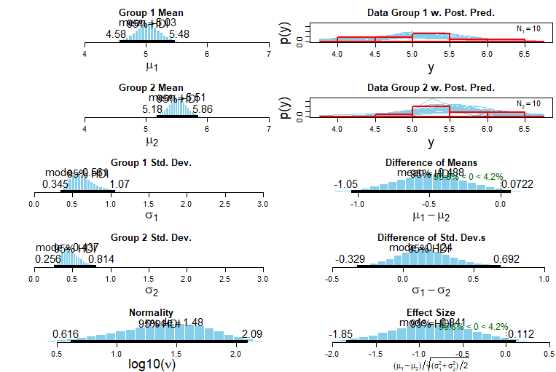

10)

> t.test(rnorm(100000,mean=17.1,sd=3.8),rnorm(100000,mean=17.2,sd=3.8))

Welch Two Sample t-test

data: rnorm(1e+05, mean = 17.1, sd = 3.8) and rnorm(1e+05, mean = 17.2, sd = 3.8)

t = -5.9883, df = 2e+05, p-value = 2.124e-09

alternative hypothesis: true difference in means is not equal to 0

95 percent confidence interval:

-0.13516104 -0.06850199

sample estimates:

mean of x mean of y

17.08851 17.19034

This very poignantly illustrates the double edged sword sample size has in research. Sample size is fantastic, albeit occasionally misleading. Here, the mean difference is incredibly small with equal standard deviations. For very large datasets, it makes our life as a p hacker overly simplistic because the number of observations provides us with more than enough artificial support to find significant differences. The context of this, fuel economy, might be negligible. However, the business case could be made if this same data was generated and the test was for daily investment returns (to be accrued and compounded daily over one’s lifetime) there may be some practical value in this significance if you really want to nickel and dime this.